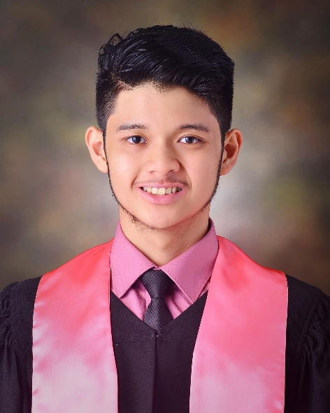

# C O N T A C T

 **Phone**

*09154845824*

## E-mail

[*karlmilanes12@gmail.com*](mailto:karlmilanes12@gmail.com)

 **Address**

*187 Sierra Madre St., San Jose*

*Vill. 3, Ph.6, Biñan, Laguna*

# E D U C A T I O N

## Adventist UNIVERSITY OF THE PHILIPPINES

BS Nutrition and Dietetics

2016-2020

## LAGUNA BELAIR SCIENCE SCHOOL

High School Graduate 2005-2015

# C E R T I F I C A T E S

# Udemy: Ultimate Web Designer & Web Developer Course

# INSTRUCTOR: Brad Hussey

Karl Shariff

D . M I L A N E S

G R A D U A T E 2 0 2 0

# P E R S O N A L P R O F I L E

Graduated from Adventist University of the Philippines with a Bachelor of Science degree in Nutrition and Dietetics

.

# T E C H N I C A L S K I LL S

Diet assessment, Nutrition Counseling, Meal Planning

OJT in Food Service,Hospital and Public Health Nutrition

Coding Languages

HTML,CSS, JavaScript

Frameworks

Bootstrap

# P E R S O NA L S K I L L S

Detail-oriented Critical Thinking Analysis

Oral and Written Communication

Can work independently and as part of a team

# Other Skills

Word 2013, Excel

and Power point

Proficient in Lead Electric Guitar, Bass Guitar and Acoustic guitar